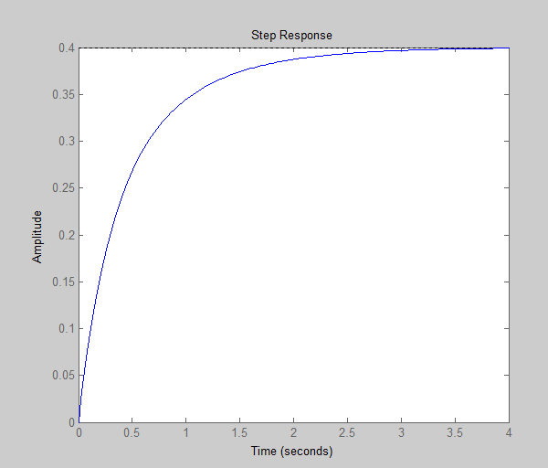>> sys1=1/(s+1)

sys1 =

1

-----

s + 1

Continuous-time transfer function.

>> sys2=(s+2)/(s+3)

sys2 =

s + 2

-----

s + 3

Continuous-time transfer function.

>> sysseries=series(sys1,sys2)

sysseries =

s + 2

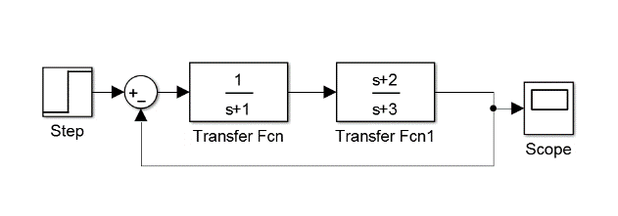 -------------

s^2 + 4 s + 3

Continuous-time transfer function.

>> sysfeedback=feedback(sysseries,1)

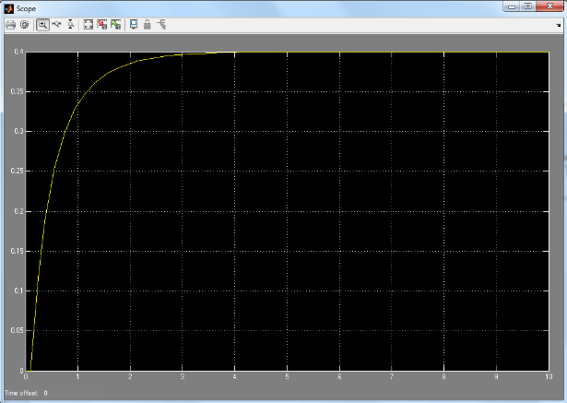sysfeedback =

s + 2

-------------

s^2 + 5 s + 5

Continuous-time transfer function.

>> figure,

>> step (sysfeedback)

HW2

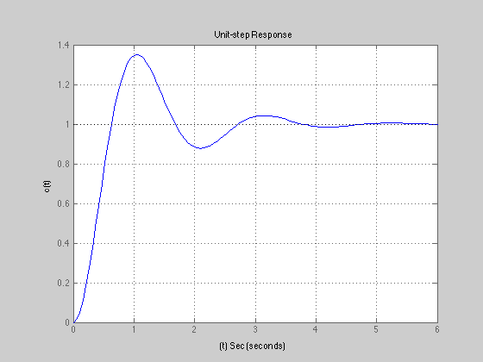

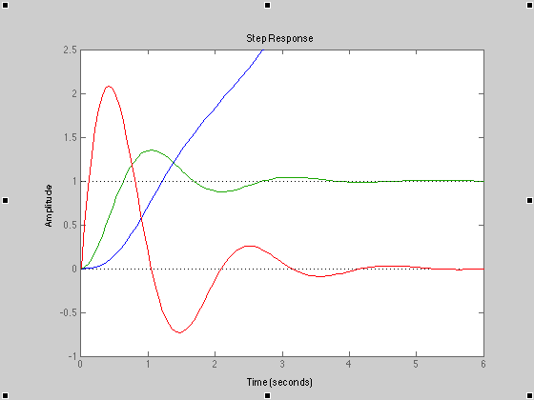

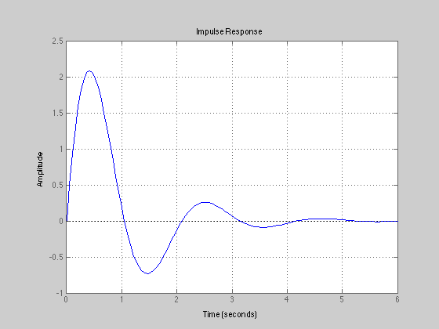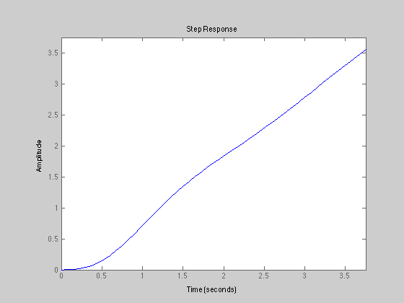

#10)

Matlab code

>> s=tf('s');

sys1=10/(s^2+2\*s+10);

>> sys1

sys1 =

10

--------------

s^2 + 2 s + 10

Continuous-time transfer function.

>> figure

>> hold on

>> grid

>> step(sys1)

>> impulse(sys1)

>> sys1=10/((s^2+2\*s+10)\*s); %for ramp func

>> step(sys1)

>> ylim([-1 2.5])

>> xlim([0 6])

>> legend('step','impulse','ramp')

>> ylabel('c(t)')

>> title('Unit-func Response')

